Description of the Technical Architecture
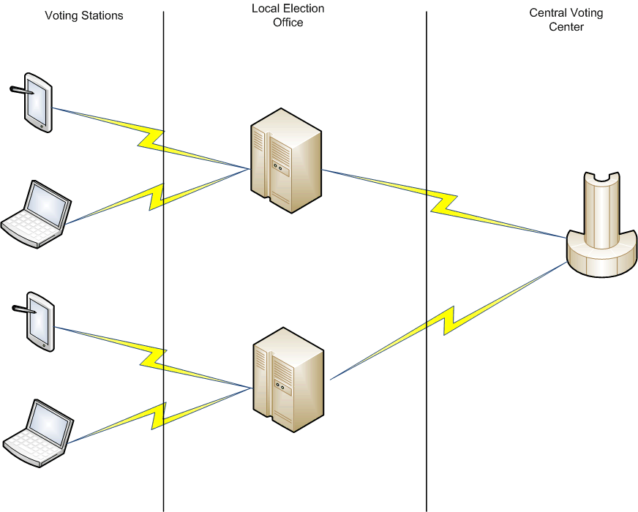
Figure: Patent (Pending) filing: Application No.: 16/200,161 DNS-based Voting Method

Just like the Domain Name System (DNS), the system leverages on a set of resolvers (Stub, Recursive, and Authoritative) that receives the votes as queries and responding with a confirmation before the vote is fully acknowledged. This forms a multi-tier architecture that record, authenticate and confirm votes.

This is where the similarities to DNS ends.

The differences lie on the following:

- The response is a confirmation that the vote is recorded; there is no need to resolve the query.
- Multiple front-end application – stub resolver – solutions could be adapted to this framework.
  - With this option, the system can support back-up paper ballots for post-election requirements.
- Servers (both Recursive and Authoritative) can be locally hosted or cloud-based solutions.
- The framework is also adaptable to the size/scope of each tier; whether they represent local counties, state/provinces, or the entire nation.

Benefits of the architecture

Listed below are the benefits of using this design:

- Secure and audit twice!
The system is designed to record the votes along three resolvers; another way of saying it is, “Write on one resolver and confirm on two other resolvers by recording the same vote.” This process also means that the record is audited - in real time - along all three resolvers before it is cast as a valid vote.
A paper ballot trail is leveraged for risk-limiting and post-election audits, as necessary.

- Leverage the latest tools and technology
This system can be developed using open-source materials and cloud resources. This allows the system to be configured unique to the requirements of each precinct, county, state (or country) with minimal adjustments. It also helps the system meet the latest technical and operational standards.

- Lower Cost
Surprisingly, this also allows the expenditure to be less than half of current election equipment costs. Why? The cost of leveraging open-source and cloud resources are significantly lower than proprietary systems that run on election equipment(s). The savings become more noteworthy as the scope of the implementation increases.

